Mrs. Harter ( 6th Grade reading/Writing)

**Week One**

**Reading (periods 2,3,6) - 1.** Read and complete short responses in “The Girl From Mango Street” packet.

**2.** Continue reading independent novels, and complete 3 reading entries in your notebook as usual.

**Writing (Periods 4,7) - 1.** Complete differentiated /labeled 30 week test in full, including evidence organizer. (Remember you must create the organizer on your own in the packet).

**2.** Read and complete evidence organizer(create your own), for “Summer Hawk”.

**Week Two**

**Reading (Periods 2,3, 6) - 1.** Go to my google classroom and complete the 3 reading/comprehension activities and submit. Students who do not have computer access should see their hard copies provided.

**2.** Continue reading independent novels, and complete 3 reading entries in your notebook as usual.

**Writing (Periods 4,7)- 1.** Complete letter to service man activity, and share with me (Google Docs)for possible revisions. Revise as needed. These will be printed out and mailed upon our return. Students without computer access, please refer to your handout for instructions. This may be done in your notebook.

**2.** Begin a poetry notebook in your writer’s notebook. Write 1 page a day of any poetry type of your choice. This could be a page of many small poems, or one large one. Use colored pencils if desired. Have fun with it! **See your packet/my website for ideas,notes,further packet activities.**

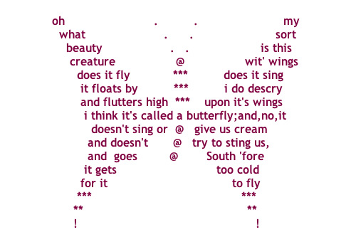

Concrete poem(Shape poetry)

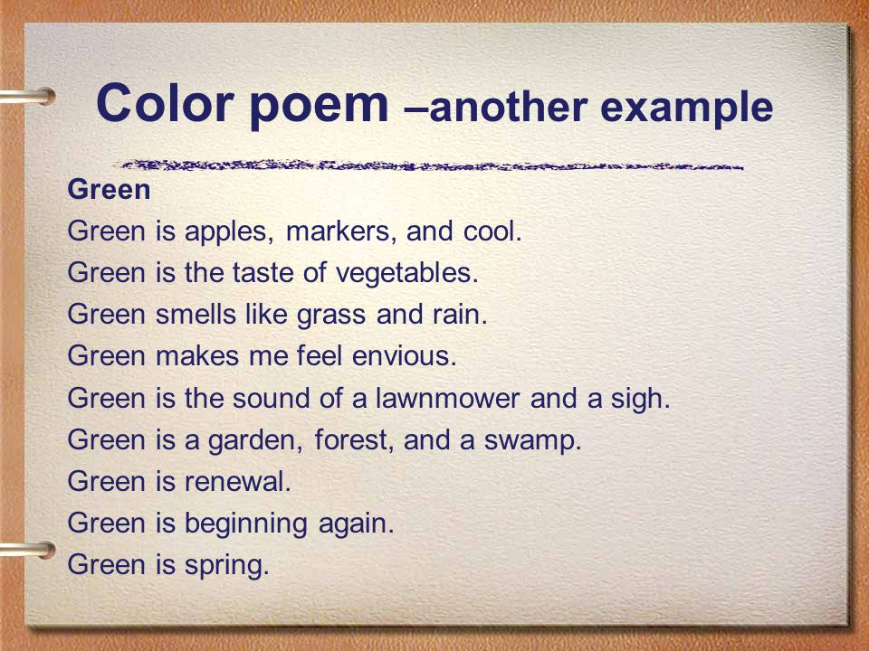

Color poetry